


SAVEETHA SCHOOL OF ENGINEERING

SAVEETHA INSTITUTE OF MEDICAL AND TECHNICAL SCIENCES

COMPUTER SCIENCE AND ENGINEERING PROGRAMME

LAB MANUAL CSA1305

THEORY OF COMPUTATION

COMPUTER SCIENCE AND ENGINEERING PROGRAMME

LIST OF EXPERIMENTS

- To write a C program to check whether a string belongs to the grammar S -> 0 S 0 | A A -> 1 A |
Ε
AIM:
To write a C program to check whether a string belongs to the grammar:
S → 0 S 0 | A
A → 1 A | ε

Apparatus Required
- Computer/Laptop
- GCC Compiler (Turbo C/GCC/CodeBlocks/VS Code)
- C Programming Language

Algorithm
- Start the program.
- Read the input string.
- Compare the characters from the beginning and end of the string.
- If all corresponding characters are equal, the string is a palindrome.
- Otherwise, the string does not belong to the grammar.
- Display the result.
- Stop the program.

Program Code

#include <stdio.h>

#include <string.h>

int main()

{

char str[100];

int len, i = 0, j, left = 0, right = 0, flag = 1;

printf("Enter the string: ");

scanf("%s", str);

len = strlen(str);

j = len - 1;

/* Count leading zeros */

while(i < len && str[i] == '0')

{

left++;

i++;

}

/* Count trailing zeros */

while(j >= 0 && str[j] == '0')

{

right++;

j--;

}

if(left != right)

flag = 0;

/* Check middle characters are only 1's */

for(i = left; i <= j; i++)

{

if(str[i] != '1')

{

flag = 0;

break;

}

}

if(flag)

printf("The string belongs to the grammar.\n");

else

printf("The string does not belong to the grammar.\n");

return 0;

}

Sample Input 1
Enter the string: 0011100

Sample Output 1
The string belongs to the grammar.

OUTPUT: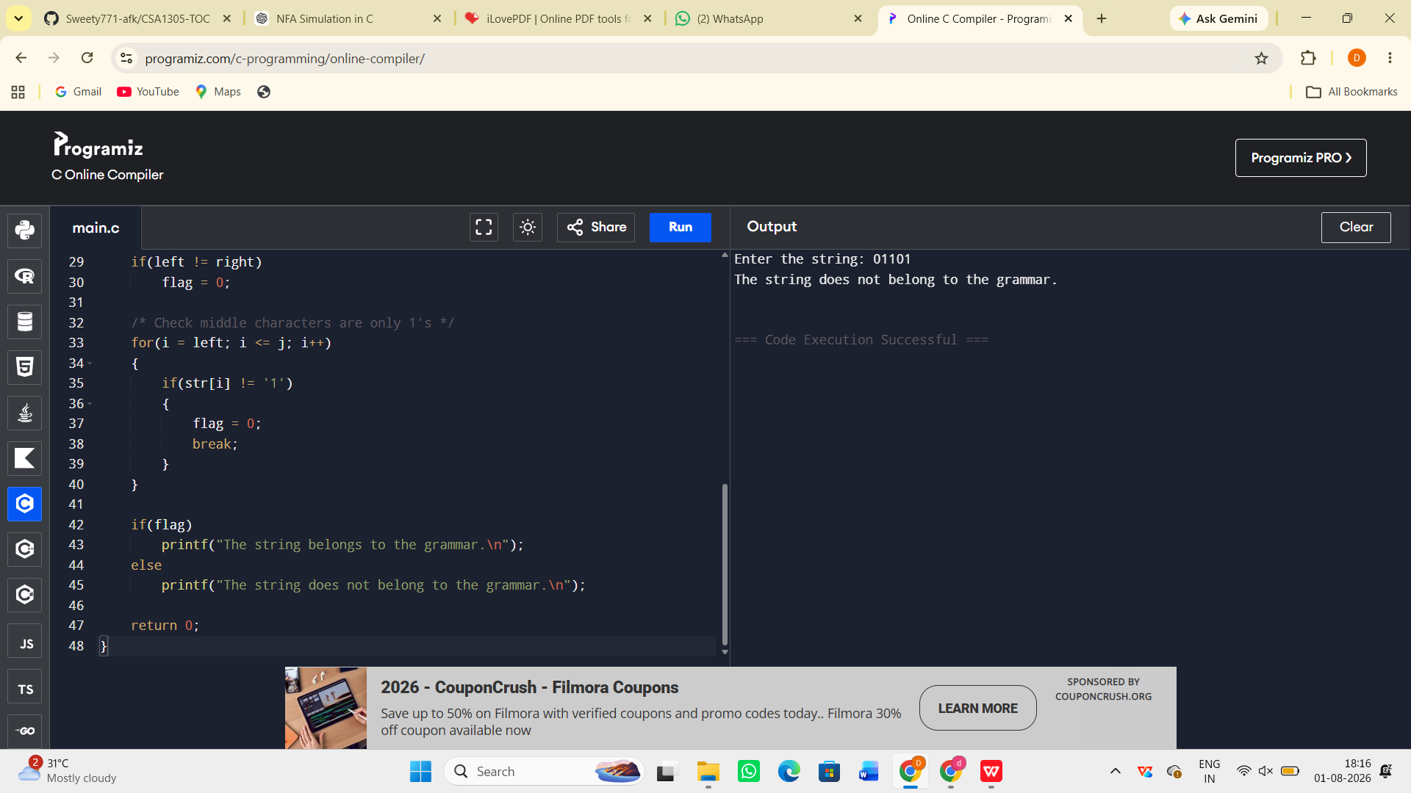

Result:
The C program to check whether a given string belongs to the grammar S → 0 S 0 | A, A → 1 A | ε was successfully implemented and executed. The program correctly accepts strings of the form 0ⁿ1ᵐ0ⁿ and rejects all other strings.

